CAS PY 106

Pre-lecture Note 11

1. Resistors in Series
2. 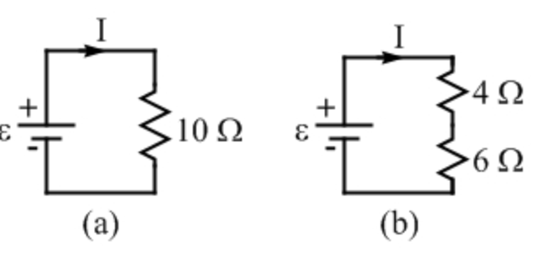
3. In many circuits, resistors are placed in series, as the figure above, so that the charge flows through resistors in sequence
4. If the 4 and 6 resistors are connected by a wire of negligible resistance, battery sees no difference between single 10 resistor and 4 and 6 resistors that are connected in series – the battery is still trying to force charge to flow through total resistance of 10.

R = R1 + R2 + … + Rn

1. Current in Series
2. Current is same at all points in series circuit
3. All the charge that flows through 4 resistor keeps going to flow through the 6 resistor
4. The rate of flow is also the same because charge cannot pile up anywhere in the circuit
5. Because current is rate of flow of charge, this means the current is same through both resistors

I = V/R = 20/10 = 2

1. Potential Difference
2. Potential difference across 4 resistor:

V = IR

V = 2 \* 4

V = 8

1. Potential difference across 6 resistor:

V = IR

V = 2 \* 6

V = 12

1. Total potential difference

V = V1 + V2

V = 8 + 12

V = 20

1. Which bulb is brighter
2. 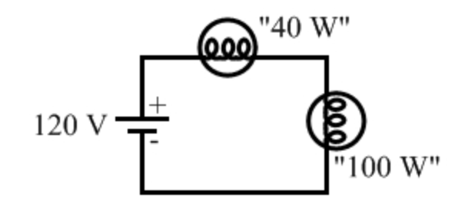
3. Standard 40W light bulb is connected in series with 100W light bulb and electric outlet (120V battery)
4. Resistance for 100W = 144
5. Resistance for 40W = 360
6. 40W light bulb shines brighter – even if the current flow is same
7. The brightness is determined by power

P = I^2\*R

1. With more resistance, it represents more power and therefore 40W light bulb shines brighter
2. Current of circuit:

V = IR

I = V/R

I = 120/(144+360)

I = 0.238

1. Power dissipated in 40W:

P = .238^2 \* 360

P = 20.4

1. Power dissipated in 100W

P = .238^2 \* 144

P = 8.16